**35**

**Image formation**

|  |
| --- |
| **CHAPTER OUTLINE** |

35.1 Images Formed by Flat Mirrors

35.2 Images Formed by Spherical Mirrors

35.3 Images Formed by Refraction

35.4 Images Formed by Thin Lenses

35.5 Lens Aberrations

35.6 Optical Instruments

* An asterisk indicates a question or problem new to this edition.

|  |
| --- |
| **SOLUTIONS TO THINK-PAIR-SHARE AND ACTIVITIES** |

**\*TP35.1** Solve Equation 35.11 for the index of refraction of the material:

 (1)

Measuring *p* and *q* with a ruler in Figure 35.19, we find their ratio to be



where we have entered *q* as negative because it is a virtual image. Therefore, from Equation (1),



*Answer:* 2.8

**\*TP35.2 Conceptualize** Be sure you are clear on how two images are formed. The inverted image is formed by light leaving the object in Figure TP35.2 and traveling to the right. Therefore, the light forming this image never encounters the mirror. The upright image is formed by light leaving the object and moving to the left. The mirror forms an image that acts as the object for the lens, resulting in a final image that is upright.

**Categorize** We model the light rays as *waves under reflection* and *refraction,* using the special cases of image formation by mirrors and lenses.

**Analyze** (a)For the inverted image, formed by the lens alone, Equation 35.19 gives us

 (1)

Equation 35.18 gives us

 (2)

Substitute Equation (1) into Equation (2):

 (3)

Substitute numerical values:



(b) Now, let’s consider the light that moves to the left toward the mirror. It will then reflect back to the right and pass through the lens. The image of the mirror will act as the object of the lens. If the final image from the combination is at the same location as the image due to the light passing through the lens alone, then the image due to the mirror must be at the same location as the original object. Therefore,

 (4)

Solve Equation 35.6 for the focal length of the mirror:

 (5)

Substitute Equation (4) into Equation (5):

 (6)

Substitute numerical values:



**Finalize** Notice that, in order to give a final upright image, the image formed by the mirror must be inverted. That is consistent with a real image formed by a concave mirror. In reality, the upright image might be a little fainter than the inverted image because it encountered two optical elements, while the inverted image only encountered one. As long as the mirror is clean and highly reflective, however, the difference should be minimal.

*Answers:* (a) 16.7 cm (b) 11.7 cm

**\*TP35.3 Conceptualize** Read the storyline again and be sure you are clear on the two activities:

(1) Lay the smartphone on the desk so that the display is upward. Hold a magnifying glass *horizontally* above the display and move it vertically until a clear image of the display appears on the ceiling; measure the distance between the smartphone display and the lens.

(2) Hold a magnifying glass *vertically* near a wall opposite a window and move it horizontally until a clear image of the outside world appears on the wall; measure the distance between the wall and the lens.

**Categorize** This problem involves the special case of the *wave under refraction* model that is applied to image formation by lenses.

**Analyze** Consider the first activity. The display–lens distance you measured is the variable *p* in Equation 35.18, the object distance. Solve Equation 35.18 for *p*:

(1)

In the second activity, the building across the street can be modeled as infinitely far away, represented as *p* → ∞. As a result, the image forms at the focal point, and the distance between the lens and the wall is the focal length of the lens:

*q* = *f* (2)

Clearly, Equations (1) and (2) are not identical. But consider the first activity again. The distance *q* in Equation (1) is the distance between the magnifying glass and the ceiling, where the image is formed. This distance, for a typical desktop magnifying glass, is several times larger than the focal length of the lens. Therefore, in the denominator, the quantity *q* – *f* is just a little smaller than *q*. Therefore, *p* in Equation (1) is just a little *larger* than the focal length *f*.

As a consequence, the measurements made in the two experiments are close, but not exact; one is the focal length of the magnifying glass, and the other is a little larger than the focal length.

Now, let’s rearrange Equation (1) and solve it for the focal length:

(3)

In the first activity, if you were to combine your measurement of *p* with a measurement *q* between the lens and the ceiling, and calculate the focal length with Equation (3), that value should be very close to the measurement made in the second activity.

**Finalize** There might still be a little difference between the focal lengths measured in the two activities. We assumed that the view outside the window in the second activity is infinitely far away. That’s not *quite* true. But it is much farther away than the ceiling is in the first activity, so the approximation made in Equation (2) is pretty good.

*Answer:* Answers will vary.

|  |
| --- |
| **SOLUTIONS TO END-OF-CHAPTER PROBLEMS** |

**P35.1** (a) Younger. Light takes a finite time to travel from an object to the mirror and then to the eye.

(b) I stand about 40 cm from my bathroom mirror. I scatter light, which travels to the mirror and back to me in time interval

 showing me a view of myself as I was then.

**P35.2** A graphical construction, shown in ANS. FIG. P35.2, produces 5 images, with images *I*1 and *I*2 directly into the mirrors from the object *O*, and (O, *I*3 , *I*4 ) and (*I*2 , *I*1 , *I*5 ) forming the vertices of equilateral triangles.



**ANS. FIG. P35.2**

**P35.3** For a plane mirror, *q = –p*. Recall from common experience that the position of an image does not shift as a viewer rotates. Thus, to a viewer looking toward a mirror that is turned by 45°, the image distance still follows this rule.

(a) The upper mirror *M*1 produces a virtual, actual-sized image *I*1 according to



As shown in ANS. FIG. P35.3, this image is a distance *p*1 above the upper mirror. It is the object for mirror *M*2, at object distance

*p*2 = *p*1 + *h*

The lower mirror produces a virtual, actual-sized, right-side-up image according to



with

 and 

Thus the final image is at distance *p*1 + *h*, behind the lower mirror.

(b) It is 

(c) 

(d) With magnification .

(e) No. Left and right are not reversed. In a top view of the periscope, parallel rays from the right and left sides of the object stay parallel and on the right and left. The first mirror switches left and right, but the second mirror switches them again; so, overall left and right are not reversed.

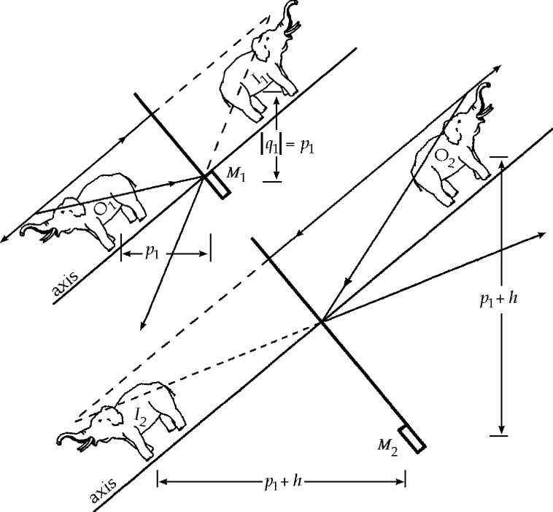

**ANS. FIG. P35.3**

**P35.4** We assume that she looks only at images in the nearest mirror. The mirrors are 3.00 m apart.

(a) With her palm located 1.00 m in front of the nearest mirror, that she sees its image 1.00 m behind the nearest mirror.

(b) The nearest mirror shows the palm of her hand.

(c) Her hand is 2.00 m from the farthest mirror, so its image forms 2.00 m behind the farthest mirror, but this image is 2.00 m + 3.00 m = 5.00 m from the nearest mirror, so the image she sees is 5.00 m behind the nearest mirror.

(d) The image is that of the back of her hand reflected in the farthest mirror.

(e) The farthest mirror forms an image of the first image of part (a), which is 1.00 m + 3.00 m = 4.00 m from the farthest mirror; this image is then 4.00 m behind the farthest mirror, so it is 4.00 m + 3.00 m = 7.00 m in front of the nearest mirror, so the image she sees is 7.00 m behind the nearest mirror.

(f) This is the image of the palm reflected back from the nearest to the farthest and back to the nearest mirror.

(g) Since all images are located behind the mirror, and all images result from light reflected in a mirror, .

**Section 35.2 Images Formed by Spherical Mirrors**

**P35.5** (a) A concave mirror is a converging mirror, so the focal length   
*f* = +20.0 cm. Then,  gives



Since *q* > 0, the image is located .

(b) 

(c) The image distance is positive, so the image is real.

(d) The magnification is negative, so the image is inverted.

**P35.6** (a) To approximate paraxial rays, the rays should be drawn so that they reflect at the vertical plane that passes through the vertex of the mirror, rather than at the mirror’s surface, as done in the textbook. For this reason, the concave surface of the mirror appears flat in ANS. FIG. P35.6.

(b) *q* = –40.0 cm, so the image is behind the mirror.

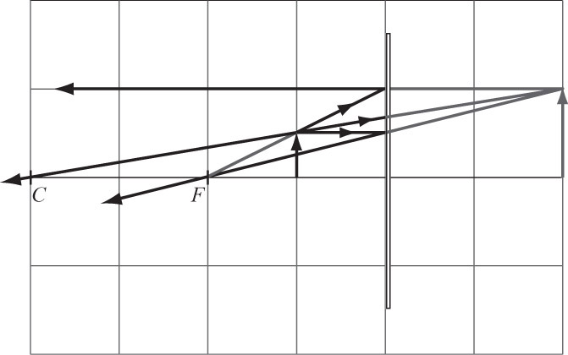

**ANS. FIG. P35.6**

(c) *M* = +2.00, so the image is enlarged and upright.

(d) The mirror is concave (converging), so *f* = +40.0 cm.



and 

**P35.7** (a) The mirror is convex (diverging), so *f* = –10.0 cm.



The image distance is negative; thus, the image is virtual. The image is 7.50 cm behind the mirror.

(b) From , we see that the magnification is positive, so the image is upright.

(c) 

**P35.8** A convex mirror *diverges* light rays incident upon it, so the mirror in this problem cannot focus the Sun’s rays to a point.

**P35.9** The niche acts as a cylindrical mirror that reflects sound. This is a mirror with a vertical axis and a radius *R* = 2.50 m: its focal length  To the extent that we can treat sound as being composed of “rays of sound,” we can find the point of focus of sound waves by using the same method we use for rays of light.

In a vertical plane the sound disperses as usual, but that radiated in a horizontal plane is concentrated in a sound image at distance *q* from the back of the niche, where





**P35.10** (a) Since the mirror is concave, *R* > 0, giving . The magnification is positive because the image is upright:



The mirror equation is then



(b) ANS. FIG. P35.10(b) shows the principal ray diagram for this situation.

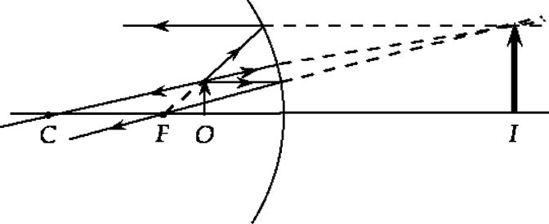

**ANS. FIG. P35.10 (b)**

(c) The image distance is negative, so the image is virtual. The rays of light do not actually come from the position of the image.

**P35.11** From the magnification equation,



which gives *q* = –0.400*p,* so the image must be virtual.

(a) It is a (diverging)  mirror that produces a diminished, upright virtual image.

(b) We must have



*p* = 42.0 cm + *q*

*p* = 42.0 cm – 0.400*p*



The mirror is 

(c)  

The ray diagram looks like Figure 35.13(c) in the text.

**\*P35.12 Conceptualize** The reflection is from a convex surface, so Figure 35.13c shows the ray diagram for this situation.

**Categorize** We model the light beams as *waves under reflection* in the special case of image formation by mirrors.

**Analyze** We first find the distance *q* from the lens at which the reflected image forms. Equation 35.2 can be used to find this quantity:

 (1)

Now, to find the radius of curvature of the reflecting surface, we use Equation 35.4 and solve for *R*:

 (2)

Substitute Equation (1) into Equation (2):

 (3)

Substitute numerical values:



**Finalize** The radius is negative because the cornea is convex, consistent with Table 35.1. An automatic calculator associated with the machine could perform the numerical value of Equation (3) based on your input of the values of *p* and *M*.]

*Answer:* –0.790 cm

**P35.13** The ball is a convex mirror with a diameter of 8.50 cm:

*R* = –4.25 cm and 

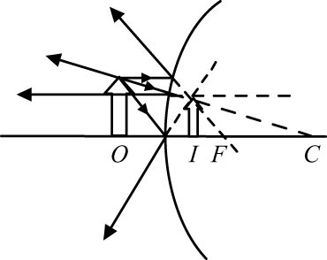

**ANS. FIG. P35.13**

(a) We have



By the mirror equation,





or 

The object is 0.708 m in front of the sphere.

(b) From ANS. FIG. P35.13, the image is upright, virtual, and diminished.

**P35.14** (a) The image starts from a point whose height above the mirror vertex is given by





As the ball falls, *p* decreases and *q* increases. Ball and image pass when *q*1 = *p*1. When this is true,



which is at the focal point.

As the ball passes the focal point, the image switches from infinitely far above the mirror to infinitely far below the mirror. As the ball approaches the mirror from above, the virtual image approaches the mirror from below, reaching it together when   
*p*2 = *q*2 = 0.

(b) The falling ball passes its real image when it has fallen



which gives 

The ball reaches its virtual image when it reaches the surface of the mirror, which is when it has traversed



which gives 

**P35.15** (a) The flat mirror produces an image according to *q* = –*p* = –24.0 cm. The image is behind the mirror, with the distance from your eyes given by



(b) The image is the same size as the object, so



(c) 



This image is behind the mirror, distant from your eyes by



(d) The image size is given by :



So its angular size at your eye is 

(e) Your brain assumes that the car is 1.50 m high and calculates its distance as



**P35.16** (a) We assume the object is real; thus the object distance *p* is positive. The mirror is convex, so it is a diverging mirror, and we have . The image is virtual, so . Since we also know that , the mirror equation gives

 or 

so *p* = +16.0 cm

This means that the object is 16.0 cm from the mirror.

(b) The magnification is .

(c) Thus, the image is  and one-third the size of the object.

**Section 36.3 Images Formed by Refraction**

**P35.17** The image forms within the rod.



(a) 

(b) 

(c) 

**P35.18** Since the center of curvature of the surface is on the side the light comes from, *R* < 0 giving *R* = –4.00 cm. For the line, *p* = 4.00 cm; then,



becomes



or *q* = –4.00 cm

Thus, the magnification  gives



**P35.19** The center of curvature is on the object side, so the radius of curvature is negative: 

(a) (i) *p* = 5.00 cm:



The image is virtual and 3.77 cm from the front wall, in the water.

(ii) *p* = 25.0 cm:



The image is virtual and 19.3 cm from the front wall, in the water.

(b) From Problem 34, the magnification is .

(i) 

(ii) 

(c) 

(d) 

(e) If , from  we have



then .

If  (but also , if the image is to be virtual—see **NOTE** below), then



and



[Assuming that .] For example, if ,



Summarizing our results:



**NOTE:** In the equation , the term  is positive because *n*1 > *n*2. If the image is to be virtual, then *q* must be negative, and so the term  must be less than *n*1/*p*:



**P35.20** Refer to Figure P35.20 in the textbook. In the right triangle lying between *O* and the center of the curved surface,  In the right triangle lying between *I* and the center of the surface, tan . We need the negative sign because the image height is counted as negative while the angle is not. We substitute into the given



to obtain



Then the magnification, defined by *M* = *h*′/*h,* is given by



**\*P35.21 Conceptualize** In this problem, we use the discussion in Section 35.3 regarding images formed by refracting surfaces. In fact, Figure 35.20 applies here if the plastic sphere is changed to a larger water sphere and the coin to a fish.

**Categorize** We model the light waves leaving the fish as *waves under refraction.*

**Analyze** (a) The wave under refraction model has given us Equation 35.9 relating the image and object positions for the fish. Solve this equation for the ratio *q*/*p* and use Equation 35.10 to find the magnification of the image, substituting the radius as –*R* because the center of curvature of the front surface of the bowl is in back of the surface.:



The largest value of *p* occurs when the fish is on the far side of the tank at *p* = 2*R*:



The smallest value of *p* occurs when the fish is right up against the glass on the near side of the bowl, *p* = 0:



Therefore, the range of magnifications of the image of the fish is



where we have not used the ≤ sign because the fish is not actually a particle and cannot place his entire body at *p* = 2*R* or *p* = 0. Substitute numerical values:



(b) Now, what about your roommate’s concern that the Sun’s rays will focus on the fish? In this part of the problem, we are looking at the refraction of the Sun’s rays as they enter the refracting surface at the *back* of the bowl. From Equation (1), find the image position for the Sun due to the curved surface of the water on which the Sun’s rays shine, with the radius of curvature as +*R*:

 (3)

Because the Sun is so far away and its rays arriving at the fishbowl are parallel, the object distance *p* is essentially infinite and the term *n*1*R* in the denominator can be neglected. Therefore,

 (4)

Substitute numerical values, keeping in mind that the Sun’s rays originate outside the bowl:

 (5)

Equation (5) tells us that the focal point of the Sun’s rays for the first refracting surface is beyond the opposite surface of the bowl, which is a distance 2*R* away. (The second surface will also refract the Sun’s rays, but the overall focal point will still be outside the bowl.) Therefore, we do not have to worry about the fish swimming through the focal point of the Sun’s rays.

**Finalize** With regard to this last point, the fish bowl will focus the Sun’s rays on a point inside the room near the fishbowl, so you may want to make sure nothing flammable is located at that point! If the fishbowl is sitting on a wooden table in the Sun, beware! (Check YouTube!)

*Answers:* (a) 1.00 < *M* < 1.99 (b) No; the light from the Sun does not focus within the bowl.

**\*P35.22 Conceptualize** In this problem, we use the discussion in Section 35.3 regarding images formed by refracting surfaces. The Sun’s rays will refract once upon entering the sphere and again upon exiting.

**Categorize** We model the light waves from the Sun encountering the sphere as *waves under refraction*.

**Analyze** The wave under refraction model has given us Equation 35.9 relating the image and object positions for a refracting surface. Solve this equation for the image position:



where *n*1 is for material surrounding the sphere (air in our example) and *n*2 is for the glass from which the sphere is made. We have also used the subscript *a* to represent quantities related to refraction at the first surface. Because the Sun is so far away and its rays arriving at the sphere are parallel, the object distance *pa* is essentially infinite and the term *n*1*R* in the denominator can be neglected. Therefore,



Now, let us consider the refraction at the second surface, for which we will use subscript *b*. We again write Equation (1) for this second refraction, but with the following considerations. For this refraction the light rays originate in the glass and exit into the surrounding material, interchanging the two indices of refraction compared to the first surface. In addition, the curvature of the glass is the opposite as for the first refraction, so the radius is negative. Let’s put the radius into the equation as –*R*, so that we can just enter the absolute value of the radius for *R* into the final equation. Equation (1) can be rewritten, with these considerations:



All measurements for both refractions are measured from the center of the spherical surface. Therefore, *pb* = –*qa* +2*R*, where the minus sign indicates that the image of the first refracting surface is on the back side of the second surface. (If we were to ignore refraction at the second surface, the Sun’s rays would focus outside the sphere due to the first surface.) Evaluate this quantity using Equation (2):



Make this substitution into Equation (3):



For a glass sphere in air, we can let *n*1 = 1 and *n*2 = *n*, so that



This distance is the position relative to the surface of the sphere at which the photocells must be placed for the Sun’s rays to focus on them.

**Finalize** Let us look at some typical values. First, notice that if *n* = 2,



The first refraction is strong enough in this case that the Sun’s rays focus on the second surface. Therefore, we must have *n* < 2 for the spherical solar concentrator to work, because the rays must exit the sphere to focus on the outside to be collected.

Let us consider another case. Suppose the sphere is made from flint glass, with *n* = 1.66. Then



And the focus point is about a quarter of the radius from the outside surface of the sphere. Based on the location of the arc on which the solar collectors ride in Figure P35.22, can you estimate the index of refraction of the sphere material? Finally, suppose we consider the sphere of water in the fishbowl in Problem 35.21. In this case,



Therefore, the Sun’s rays focus at about a distance of the radius away from the surface of the bowl. If the bowl is sitting on a wooden table, this focusing of the rays could occur right on the surface of the table and set it on fire!

*Answer:* The track must be placed a radial distance from the outer surface of .

**Section 35.4 Images Formed by Thin Lenses**

**P35.23** (a) From the mirror-and-lens equation,



so 

(b) 

(c) Since *f* > 0, the lens is 

**P35.24** (a)We are told that *p* = 5*f*. From the thin lens equation,  we have



or 

The image distance is positive, hence the image is real.



(b) 

(c) From part (a), the image distance is positive, hence the image is 

**P35.25** Let *R*1 = outer radius and *R*2 = inner radius:



so 

**P35.26** Your scale drawings should look similar to those given below:

(i) See diagram in ANS. FIG. P35.26(i).

(a) A carefully drawn-to-scale version of ANS FIG. P35.26(i) should yield an inverted image 20.0 cm in back of the lens and the same size as the object.

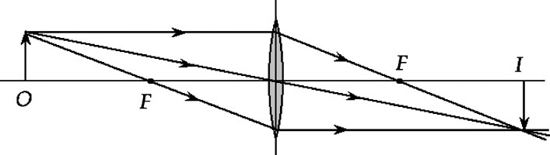

**ANS. FIG. P35.26 (i)**

(b) The image forms behind the lens, so the image is real.

(c) The figure shows that the image is inverted.

(d) The height of the image is the same as the height of the object, so *M* = –1.00.

(e) : 

A positive image distance means that the image is real.

The magnification is 

A negative magnification means that the image is inverted.



(ii) See diagram in ANS. FIG. P35.26(ii).

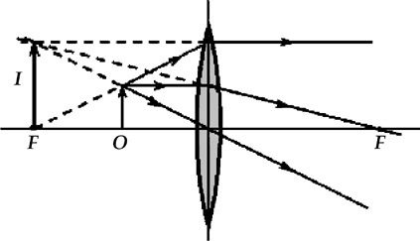

**ANS. FIG. P35.26 (ii)**

(a) A carefully drawn-to-scale version of ANS FIG. P35.26 (ii) should yield an upright, virtual image located 10 cm in front of the lens and twice the size of the object.

(b) The image forms in front of the lens, so the image is virtual.

(c) The figure shows that the image is upright.

(d) The height of the image is twice that of the object, so   
*M* = +2.00.

(e) : 

A negative image distance means that the image is virtual.

The magnification is 

A positive magnification means that the image is upright.



(f) 

P35.27 In parts (a) and (b), the images are real, so the image distances are positive.

(a) *q* = +20.0 cm:



The object distance is positive, so the object is real.

The object is 20.0 cm from the lens on the front side.

(b) *q* = +50.0 cm:



The object distance is positive, so the object is real.

The object is 12.5 cm from the lens on the front side.

(c and d) Now, the images in parts (a) and (b) are virtual, so the image distances are negative.

(c) *q* = –20.0 cm:



The object distance is positive, so the object is real.

The object is 6.67 cm from the lens on the front side.

(d) *q* = –50.0 cm:



The object distance is positive, so the object is real.

The object is 8.33 cm from the lens on the front side.

**P35.28** From the thin lens equation, since the focal length of the lens is constant,

: 

Differentiating both sides with respect to  then gives



**\*P35.29 Conceptualize** The ray diagram for this situation is shown below..

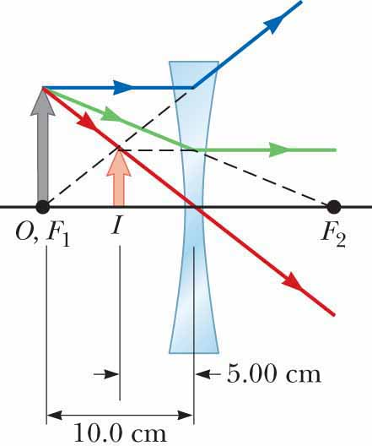

**Categorize** We use equations developed for images from lenses, so we categorize the problem as a substitution problem.

(a) Find the image distance from Equation 35.18:



Note that the image lies on the same side of the lens as the object.

(b) Find the magnification from Equation 35.19:



(c) For an object placed at the focal point of a converging lens, we cannot see the image. It is infinitely far away and of infinite magnification.

*Answers:* (a) –5.00 cm (b) +0.500 (c) The image from a converging lens of an object placed at the focal point is infinitely far away and of infinite magnification.

**P35.30** (a) 



(b) See ANS. FIG. P35.30(b).

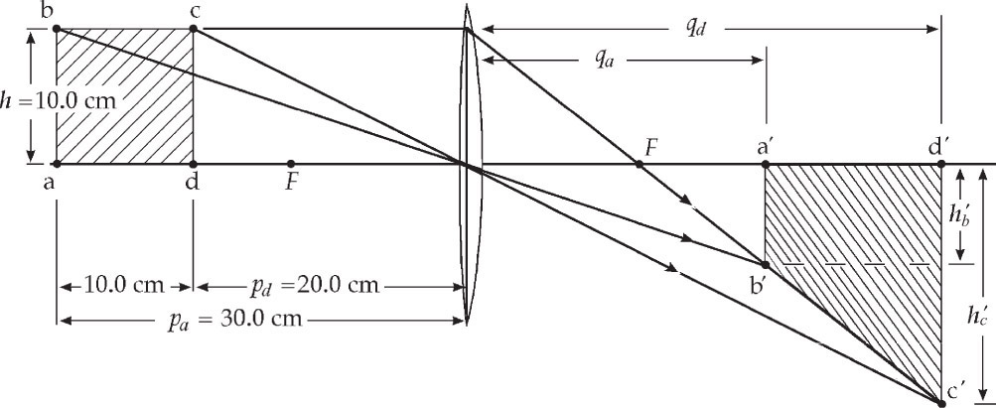

**ANS. FIG. P35.30 (b)**

The square is imaged as a trapezoid.

(c) The equation follows from  and 

 becomes  or 



(d) 

(e) We have



**\*P35.31 Conceptualize** This arrangement is a practical application of the object–lens–image situation shown in Figure 35.27a. As the object (the digital display) is moved closer to the lens (radially outward from the center of the cylinder), the focused image (on the wall or ceiling) moves farther away from the lens.

**Categorize** The lens is *converging* and, as described by Figure 35.27a, it casts a *real image* of the digital display onto the ceiling or wall.

**Analyze** (a) The problem states that the image closest to the lens is formed when the digital display is at the center of the cylinder. Therefore, the object distance for this situation is the radius of the cylinder: *p* = *R*. Using Equation 35.18,

 (1)

Substitute numerical values, using the smallest value of the image distance:



(b) Now, when the image is at the other end of the range, find the object position, using Equation 35.18 again:

 (2)

Substitute numerical values, using the largest value of the image distance:



Therefore, the distance of the display from the center of the cylinder in this situation is



**Finalize** Notice that the digital display only needs to move less than 2 mm to cover the entire range. A gear system allows fine movement of the digital display using a knob on the cylinder. Notice also in part (b) that the object, the digital display, is still farther from the lens than the focal point, as it must be to form a real image.

*Answers:* (a) 3.05 cm (b) 0.17 cm

**P36.32** Let the object distance be *p*. Then the image distance is *d* – *p*. Set up the lens equation:



Rearrange the equation to generate the following quadratic equation:



Solve with the quadratic formula:

 **[1]**

Substitute numerical values:



This expression has no real solutions. Therefore, we cannot find even one position between the object and the screen at which an image is formed on the screen. From equation [1], we see that a real value of *p* will result only if *d*2 > 4*df*, or *d* > 4*f*, in which case the plus/minus sign in equation [1] will give us two real values for *p*.

**Section 35.5 Lens Aberrations**

**P35.33** Ray *h*1 is undeviated at the plane surface and strikes the second surface at angle of incidence given by



Then,



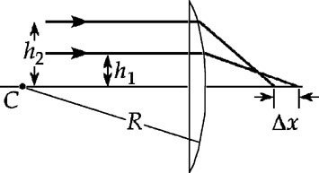

**ANS. FIG. P35.33**

The angle this emerging ray makes with the horizontal is .

The ray crosses the axis at a point farther out by *f*1 (the focal length):



Because of the curved surface of the lens, the point of exit for this ray is horizontally slightly to the left of the lens vertex (where the principal axis intersects the curved surface of the lens), by the distance



Therefore, ray *h*1 crosses the axis at this distance from the vertex:



Now we repeat the above calculation for ray *h*2:



Then,





Now 

**Section 35.6 Optical Instruments**

**P35.34** The lens should take parallel light rays from a very distant object   
(*p* = ∞) and make them diverge from a virtual image at the Josh’s far point, which is 25.0 cm beyond the lens, at *q* = –25.0 cm.

(a) 

(b) The power is negative: a 

**P35.35** To properly focus the image of a distant object, the lens must be at a distance equal to the focal length from the film (*q*1 = 65.0 mm). For the closer object:



becomes ,

and 

The lens must be moved  by a distance



**P35.36** *fo* = 20.0 m, *fe* = 0.025 0 m

(a) From Equation 35.27, The angular magnification produced by this telescope is



(b) Since *m* < 0, the image is.

**P35.37** Using Equation 35.26,



**\*P35.38 Conceptualize** Study Figure 35.41b for the situation in which a magnifying glass forms an enlarged image of an object placed inside the focal point. The maximum angular magnification occurs when the image is located at the near point of the eye. When the eye is relaxed, the image is at infinity.

**Categorize** We determine results using equations developed in Section 35.6, so we categorize this problem as a substitution problem.

(a) Evaluate the maximum angular magnification from Equation 35.24:



(b) Evaluate the minimum angular magnification, when the eye is relaxed, from Equation 35.25:

]

*Answers:* (a) 3.5 (b) 2.5

P35.39 (a)  The patient needs corrective action in both the near vision (to allow clear viewing of objects between 45.0 cm and the normal near point of 25.0 cm) and the distant vision (to allow clear viewing of objects more than 85.0 cm away). A single lens solution is for the patient to wear a bifocal or progressive lens. Alternately, the patient must purchase two pairs of glasses, one for reading, and one for distant vision.

(b) To correct the near vision, the lens must form an upright, virtual image at the patient’s near point (*q* = –45.0 cm) when a real object is at the normal near point (*p* = +25.0 cm). The thin-lens equation gives the needed focal length as



so the required power in diopters is



(c) To correct the distant vision, the lens must form an upright, virtual image at the patient’s far point (*q* = –85.0 cm) for the most distant objects (). The thin-lens equation gives the needed focal length as *f* = *q* = –85.0 cm, so the needed power is



**\*P35.40 Conceptualize** We know that the *f*-number is related to the lens diameter. We also know that it is related to light intensity, so changing the *f*-number will change the time interval required to have the same energy delivered to a given area on the CCD.

**Categorize** This problem is categorized as a substitution problem based on what we have learned about the *f*-number in the problem.

(a) Solve the definition of the *f*-number for the diameter of the lens:



(b) From Equation 16.38, we can find an expression for the energy delivered per unit area of light on the CCD:

 (1)

Therefore, if we want the energy delivered per unit area on the CCD to be the same for setting 1 and setting 2, we must have

 (2)

According to the problem statement, the intensity of radiation reaching the CCD is proportional to the inverse of the square of the *f*-number, so Equation (2) becomes



Substitute numerical values:



where we have converted the final answer to be in the form of an exposure setting on a camera.]

*Answers:* (a) 31 mm (b) ~  s

P35.41 (a) When the child clearly sees objects at her far point  the lens-cornea combination has assumed a focal length suitable for forming the image on the retina (*q* = 2.00 cm). The thin-lens equation gives the optical power under these conditions as



When the eye is focused (*q* = 2.00 cm) on objects at her near point the optical power of the lens-cornea combination is



Therefore, the range of the power of the lens-cornea combination is 

(b) If the child is to see very distant objects () clearly, her eyeglass lens must form an erect, virtual image at the far point of her eye (*q* = –125 cm). The optical power of the required lens is



Since the power, and hence the focal length, of this lens is negative, it is 

**P35.42** (a) The mirror-and-lens equation, , gives



Then,



gives 

(b) For *p* >> *f*, . Then, 

(c) Suppose the telescope observes the space station at the zenith:



**P35.43**

 so 

and 0.066 7 = 0.066 7.

They agree.



**Additional Problems**

**P35.44** The real image formed by the concave mirror serves as a real object for the convex mirror with *p* = 50 cm and *q* = –10 cm. Therefore,

 

gives *f* = –12.5 cm and .

**P35.45** Only a diverging lens gives an upright, diminished image. Therefore, the image is virtual and between the object and the lens (the image is closer to the lens), and *q* < 0. We have

, and 

so *q* = –*Mp* and *d* = *p* – *Mp.*

Therefore, :



**P35.46** For a single lens, an object and its image cannot be on opposite sides of the lens if the image is upright. The object and image must be on the same side of the lens; thus the image is virtual, and *q* < 0. Because the image is upright, *M* > 0.

If the image is between the object and the lens (the image is closer to the lens), we have

, so *q* = *d* – *p*:

 so 

Substituting into the thin lens equation,  gives



Solving,





Since *M* is positive, the lens is diverging.

If the object is between the image and the lens (the object is closer to the lens), the lens is converging. We have



Substituting into the thin lens equation,  gives



Solving,





Since *M* is positive, the lens is converging.

P35.47 The lens for the left eye forms an upright, virtual image at *qL* =   
–50.0 cm when the object distance is *pL* = 25.0 cm, so the thin lens equation  gives its focal length as



Similarly for the other lens, *qR* = –100 cm when *pR* = 25.0 cm, and *fR* = 33.3 cm.

(a) Using the lens for the left eye as the objective,



(b) Using the lens for the right eye as the eyepiece and, for maximum magnification, requiring that the final image be formed at the normal near point (*qe* =–25.0 cm) gives the object distance for the eyepiece as



The maximum magnification by the eyepiece is then



and the image distance for the objective is



The thin lens equation then gives the object distance for the objective as



The magnification by the objective is then



and the overall magnification is



**P35.48** (a) We start with the final image and work backward. From Figure P35.48, the final image is virtual (to left of lens 2) and *x* = 30.0 cm, so



The thin lens equation then gives



The image formed by the first lens serves as the object for the second lens and is located 10.0 cm in front of the second lens.

Thus, *q*1 = 50.0 cm – 10.0 cm = 40.0 cm and the thin lens equation gives



The original object should be located 13.3 cm in front of the first lens .

(b) The overall magnification is



(c) Since *M* < 0, the final image is .

(d) Since *q*2 < 0, it is .

**P35.49** Use the lens makers’ equation, Equation 35.17, and the conventions of Table 35.2. The first lens has focal length described by



For the second lens



Let an object be placed at any distance *p*1 large compared to the thickness of the doublet. The first lens forms an image according to



This virtual (*q*1 < 0) image (to the left of lens 1) is a real object for the second lens at distance *p*2 = –*q*1. For the second lens



Then  so the doublet behaves like a single lens with .

**P35.50** (a) When the meterstick coordinate of the object is 0, its object distance is *pi* = 32 cm. When the meterstick coordinate of the object is *x*, its object distance is *p* = 32 cm – *x*. The image distance from the lens is given by the thin lens equation,  (in the following, all variables are in units of cm, and units are suppressed). Substituting,



Solving for *q* then gives



The image distance *q* is measured from the position of the lens. The image coordinate on the meterstick is





(b) The image starts at the position *xi'* = 171 cm and moves in the positive *x* direction, faster and faster, and as the object approaches the position *x* = 6 cm (the focal point of the lens), the image goes out to infinity. At the instant the object is at *x* = 6 cm, the rays from the top of the object are parallel as they leave the lens: their intersection point can be described as at *x'* = ∞ to the right or equally well at *x'* = –∞ on the left. From *x'* = –∞ the image continues moving to the right, now slowing down. It reaches, for example, –280 cm when the object is at 8 cm, and –55 cm when the object is finally at 12 cm.

|  |  |
| --- | --- |
| object position (cm) | image position (cm) |
| *x* | *x'* |
| 0 | 170.7 |
| 1 | 193.2 |
| 2 | 227.0 |
| 3 | 283.3 |
| 4 | 396.0 |
| 5 | 734.0 |
| 6 | infinity |
| 7 | –618.0 |
| 8 | –280.0 |
| 9 | –167.3 |
| 10 | –111.0 |
| 11 | –77.2 |
| 12 | –54.7 |

(c) 

(d) 

**P35.51** For the first lens, the thin lens equation gives



The first lens forms an image 4.00 cm to its left. The rays between the lenses diverge from this image, so the second lens receives diverging light. It sees a real object at distance

*p*2 = *d –* (–4.00 cm) = *d* + 4.00 cm

For the second lens, when we require that  the mirror-lens equation becomes *p*2 = *f*2 = 12.0 cm.

Since the object for the converging lens must be 12.0 cm to its left, and since this object is the image for the diverging lens, which is 4.00 cm to **its** left, the two lenses must be separated by 8.00 cm.

Mathematically,



**P35.52** For the first lens, the thin lens equation gives



We require that  for the second lens; the thin lens equation gives *p*2 = *f*2, where, in this case,



Therefore, from 



**P35.53** (a) In the first situation, , and



where *f*, *p*, and *q* are in meters.

Substituting, we have .

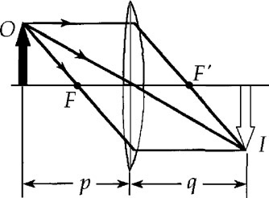

**ANS. FIG. P35.53**

(b) In the second situation, 

*p*2 = *p*1 + 0.900 m and *q*2 = *q*1 – 0.900 m = 0.600 m – *p*1,

where *f*, *p*, and *q* are in meters.

Substituting, we have 

(c) Both lens equation are equal:





Simplified, this becomes





(d) From part (a), :



**P35.54** (a) Have the beam pass through the diverging lens first, then the converging lens. The rays of light entering the diverging lens are parallel, so they behave as though they come from an object at infinity (*p* = ∞):

 

or *q* = –12.0 cm.

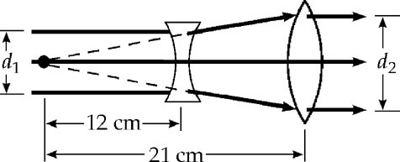

**ANS. FIG. P35.54**

Use this image as a real object for the converging lens, placing it at the focal point on the object side of the lens, at *p* = 21.0 cm. Then



or *q* = ∞.

The exiting rays will be parallel. The lenses must be 21.0 cm –   
12.0 cm = 9.00 cm apart.

(b) Refer to ANS. FIG. P35.54. By similar triangles,

 

**P35.55** Find the image position for light traveling to the left through the lens:



Therefore, this image forms 0.600 m to the left of the lens. Find the image formed by light traveling to the right toward the mirror from an object distance of 1.30 m – 0.300 m = 1.00 m:



Solving and substituting numerical values gives



This image forms at the position of the original object. Therefore, as light continues to the left through the lens, it will form an image at a position 0.600 m to the left of the lens. As a result, *both* images form at the *same* position and there are not two locations at which the student can hold a screen to see images formed by this system.

**Challenge Problems**

**P35.56** (a) From the thin lens equation,



and, from the definition of magnification,



Then, for a combination of two lenses,



or



From the thin lens equation for the second lens,



So the distance between the object and the screen is



(b) In the following, if no units are shown, assume all distances (*p*, *q*, and *f*) are in units of cm.

For lens 1, we have . Solve for  in terms of :

 **[1]**

Now we have , using [1]. From , we have



 **[2]**

Substitute [2] into the lens equation for lens 2, , and obtain  in terms of :

 **[3]**

Substitute [3] into [2], to obtain  in terms of :

 **[4]**

We know that the distance from object to the screen is a constant:

 a constant **[5]**

Using [1], [3], and [4], and the value obtained in part (a), [5] becomes

 **[6]**

Multiplying equation [6] by , we have



This reduces to the quadratic equation



which has solutions  and 6.573 cm.

Case 1: 



From [4]: 



Case 2: 



From [4]: 



From these results it is concluded that:



**P35.57** First, we solve for the image formed by light traveling to the left through the lens. The object distance is *pL* = *p*, so



Next, we solve for the image formed by light traveling to the right and reflecting off the mirror. The object distance is *pM* = *d* – *p*, so



If *qM* is positive (real image), the image formed by the mirror will be to its left, and if *qM* is negative (virtual image), the image formed by the mirror will be to its right; for either case, the image formed by the mirror acts as an object for the lens at a distance :



We solve for the position of the final image q′L:



For the two images formed by the lens to be at the same place,



Therefore,



Solving for *d* then gives



Therefore, 

**P35.58** (a) The object is located at the focal point of the upper mirror. Thus, the upper mirror creates an image at infinity (i.e., parallel rays leave this mirror). For the upper mirror, the object is real, and the mirror equation,  gives



The lower mirror focuses these parallel rays at its focal point, located at the hole in the upper mirror. For the lower mirror, the object is virtual (behind the mirror), :

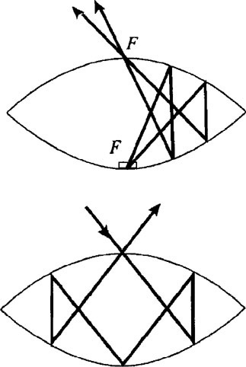

**ANS. FIG. P35.58**



The overall magnification is



Thus, the .

(b) Light travels the same path regardless of direction, so light shined on the image is directed to the actual object inside, and the light then reflects and is directed back to the outside. Light directed into the hole in the upper mirror reflects as shown in the lower figure, to behave as if it were reflecting from the image.

|  |
| --- |
| **ANSWERS TO QUICK-QUIZZES** |

**1.** false

**2.** (b)

**3.** (b)

**4.** (d)

**5.** (a)

**6.** (b)

**7.** (c)

|  |
| --- |
| **ANSWERS TO EVEN-NUMBERED PROBLEMS** |

**P35.2** See ANS. FIG. P35.2

**P35.4 (a)** 1.00 m behind the nearest mirror;

**(b)** the palm;

**(c)** 5.00 m behind the nearest mirror;

**(d)** the back of her hand;

**(e)** 7.00 m behind the nearest mirror;

**(f)** the palm;

**(g) **

**P35.6** (a) See ANS FIG P35.6; (b) *q* = –40.0 cm, so the image is behind the mirror; (c) *M* = +2.00, so the image is enlarged and upright; (d) See P35.6 (d) for full explanation.

**P35.8** A convex mirror *diverges* light rays incident upon it, so the mirror in this problem cannot focus the Sun’s rays to a point.

**P35.10** (a) 8.00 cm; (b) See ANS. FIG. P35.10 (b); (c) virtual

**P35.12** –0.790 cm

**P35.14** (a) See ANS P35.14 for full explanation; (b**) , **

**P35.16** (a) 16.0 cm from the mirror; (b) +0.333; (c) upright

**P35.18 **

**P35.20** See ANS P35.20 for full explanation

**P35.22** The track must be placed a radial distance from the outer surface of .

**P35.24** (a) The image is in back of the lens at a distance of 1.25*f* from the lens; (b) –0.250; (c) real

**P35.26** (i) See ANS. FIG P35.26(i): (a) 20.0 cm in back of the lens, (b) real,   
(c) inverted, (d) *M* = –1.00, (e) Algebraic answers agree, and we can express values to three significant figures: *q* = 20.0 cm, *M* = –1.00;   
(ii) See ANS. FIG. P35.26(ii): (a) 10 cm front of the lens, (b) virtual,   
(c) upright, (d) *M* = +2.00, (e) Algebraic answers agree, and we can express values to three significant figures: *q* = –10.0 cm, *M* = +2.00,   
(f) Small variations from the correct directions of rays can lead to significant errors in the intersection point of the rays. These variations may lead to the three principal rays not intersecting at a single point.

**P35.28** 

**P35.30** (a) *qa* = 26.3 cm, *qd* = 46.7 cm, –8.75 cm, –23.3 cm; (b) See ANS. FIG. P35.30(b); (c) See P35.30(c) for full explanation; (d) The integral stated adds up the areas of ribbons covering the whole image, each with vertical dimension |*h*′| and horizontal width *dq*; (e) 328 cm2.

**P35.32** See ANS P35.32 for full explanation

**P35.34** (a) –4.00 diopters; (b) diverging lens

**P35.36** (a) –800; (b) inverted

**P35.38** (a) 3.5 (b) 2.5

**P35.40** (a) 31 mm (b) ~  s

**P35.42** (a) See P35.42(a) for full explanation; (b) ; (c) –1.07 mm

**P35.44 **

**P35.46**  when the lens is diverging;  when the lens is converging

**P35.48** (a) 13.3 cm in front of the first lens; (b) –6.00; (c) inverted; (d) virtual

**P35.50** (a)  where *x* and *x*′ is are in centimeters; (b) See P35.50(b) for full explanation; (c) The image moves to infinity and beyond—meaning it moves forward to infinity (on the right), jumps back to minus infinity (on the left), and then proceeds forward again; (d) The image usually travels to the right, except when it jumps from plus infinity (right) to minus infinity (left).

**P35.52 **

**P35.54** (a) See P35.54(a) for full explanation; (b) 1.75 times

**P35.56** (a) 67.5 cm; (b) The lenses can be displaced in two ways. The first lens can be moved 1.28 cm farther from the object and the second lens 17.7 cm toward the object. Alternatively, the first lens can be moved 0.927 cm toward the object and the second lens 4.44 cm toward the object.

**P35.58** (a) The image is real, inverted, and actual size; (b) Light travels the same path regardless of direction, so light shined on the image is directed to the actual object inside, and the light then reflects and is directed back to the outside. Light directed into the hole in the upper mirror reflects as shown in the lower figure, to behave as if it were reflecting from the image.